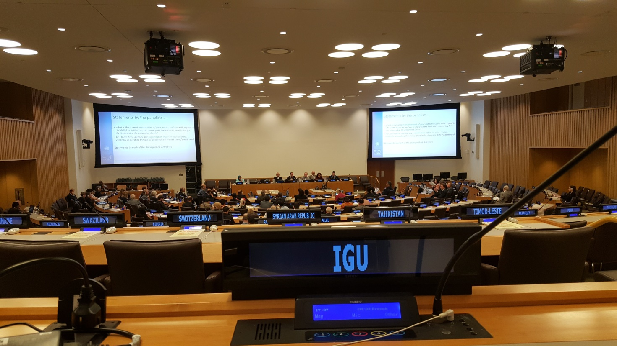UNITED NATIONS GROUP OF EXPERTS ON GEOGRAPHICAL NAMES (UNGEGN)
11th UN Conference and 30th Session of the United Nations Group of Experts on Geographical Names 7 & 18 August 2017, New York
New York, 8-17 August 2017

The 11th UN Conference on the Standardization of Geographical Names was held from 8 to 17 August 2017 in the Conference Room 3 of the United Nations in New York, NY 10017 USA.
About 60 State Members of the United Nations gathered in 23 divisions, that make up the UNGEGN according to a rough-and ready linguistic rule, were registered. In addition 8 representatives or observers (from IGU, ICANN, ICA, Names Society of Southern Africa, ESRI, Google, Universitad Nacional de Columbia, DGACM, The make Things Workshop, AISI-CIG, Wuhan University) were registered. This list was completed by 7 people of the United Nations Secretariat.
The Conference begins with reflection on the past and future for the fiftieth anniversary of the United Nations Conference on the Standardization of Geographical Names. Some national and international meetings, conferences, symposiums, publicity and publications follow, with the report by the International Hydrographic Organization, the activities of the joint IGU/ICA Commission on Toponymy, the International Map Year 2015-2016 (submitted by Liaison Officer of ICA), Place names day and place names Bee in Latvia, The International Symposium on Application of Marine Geophysical Data and Undersea Feature Names, the International Seminar on Sea Names. Some national standardizations follow, with the description of administrative structure of national names authorities, legislation, policies and procedures. Toponymic guidelines for map editors and other editors. Geographical Names as culture, heritage and identity (including indigenous, minority and regional language names), Toponymic data files and gazetteers , Exonyms, Writing systems and pronunciation, Country names. Terminology in the standardization of geographical names. Toponymic education. Features beyond a single sovereignty and international cooperation. Arrangements for the twelfth Conference. Draft organization of work.
During the Conference some special presentations (on UN-GGIM, A reflection of UNGEGN Capacity building programme and communication and publication activities, Title TBD, Geographical names standardization in Africa: challenges and constraints, New York City urban names, Positioning geospatial information to address global challenges, “Mapping our Seas, Oceans and Waterways – more important than ever”, “Field Names in the Tyrol (Austria), Collection, Standardization and cultural aspects”, “Location and Place Names in creating the Smart, Sustainable, and Resilient Communities of the Future”, Title TBD”, “Māori geographical naming in New Zealand, with emphasis on the Treaty of Waitangi”, SALB) were presented.
The following panels were discussed: National Names Authorities, Geographical Names as Cultural Heritage, Making Geographical Names Data Accessible and Available, UN resolutions of exonyms: witnesses of the past or guidelines still observed? , Writing names in so-called non-written languages. Support of geographical names data files and gazetteers to UN-GGIM activities like the SDG’s and 2030 Agenda
The plenary presentations were: Measures taken and proposed to implement United Nations resolutions on the standardization of geographical names, including the economic and social benefits, Reports on the work of the United Nations Group of Experts on Geographical Names, its divisions, working group and task team since the Tenth Conference, Reports by Governments on the situation in their countries and on the progress made in the standardization of geographical names in the standardization of geographical names since the Tenth Conference.
During the lunch time some meetings were organized to set out particular problems.

For the documents presented during the 30th Session of the United Nations Group of Experts on Geographical Names 7 & 18 August 2017, New York see: https://unstats.un.org/UNSD/geoinfo/UNGEGN/ungegnConf11.html.
Among the interesting discussions I would like to emphasize the following ones:
- The Romanization of the geographical names,
- The standardization of geographical names,
- The training in toponymy
- The exonyms,
- The cultural heritage,
- The naming of indigenous people place names.

But the most important issues are the Romanization of the geographical names , the training in toponymy and the exonyms, Peeter Päll presented a report which I enclose as well I enclose the program of Icute for the training in toponymy, while Peter Jordan has discussed many years about the exonyms. Peter Jordan also presented a report on our IGU-ICA Joint Commission on Toponymy.

Peter Raper (RSA): University of the Free State [Chairperson] [2015]
Paulo Marcio Leal de Menezes (Brazil): Federal University of Rio de Janeiro [2015]
Peter Jordan (Austria): Austrian Academy of Science [2015]
Cosimo Palagiano (Italy): Sapienza Università di Roma [2015]
Theo du Plessis (RSA): University of the Free State [2015]
Jani de Lange (RSA): University of the Free State [Secretary] [2016]

Members:
Tendai Mangena (Zimbabwe): Great Zimbabwe University [2016]
Tjeerd Tichelaar (Netherlands): Noordhoff Publishers [2016]
Trueman Khubheka (RSA): Department Sports, Arts and Culture [2016]
Ferjan Ormeling (Netherlands): Ultrecht University [2016]
Pier-Giorgio Zaccheddu (Germany): Federal Agency for Cartography and Geodesy [2016]
Brahim Atoui (Algeria): National Council of Geographical Information [2016 ]

Cosimo Palagiano
IGU Chair of IGU-ICA Joint Commission on Toponymy
(http://igu-icatoponymy.org)

Working Group on Romanization Systems meeting 11th August 2017, United Nations, New York The Working Group on Romanization Systems (WGRS) met in the course of the 11th UN Conference on the Standardization of Geographical Names on the morning of 11th August 2017. The Convenor welcomed the participants and thanked them for their attendance. The WG studied and approved the proposed agenda: 1. Romanization of Arabic 2. Romanization of Sinhala 3. Romanization of the Indian group of languages 4. Other romanization issues 5. Convenorship of the WG and future plans 6. Any other business Under item 1, Romanization of Arabic The Working Group considered in some detail the draft resolution on the romanization of Arabic geographical names that was being put to the 11th UNCSGN on behalf of the Arabic Division. The Convenor described the background to the currently approved UN system (1972), noting that a new system had been on the agenda of the Arabic Division for a long time, and described the evolution of the new proposal (2007). WGRS’s views on the system had been solicited and a side meeting had been held during the previous WGRS meeting in Prague, April 2017. Comments resulting from this meeting had been compiled and submitted to the Arabic Division, and these comments had in turn been considered in a meeting held in May 2017 in Riyadh attended by the WGRS Convenor and UNGEGN Chair. Participants from the Arabic Division recorded their views, mostly in support of the draft Resolution though particular objections from Algeria were recorded. It was noted that the Resolution’s text included scope for the system not to be adopted in areas where it was not felt to be applicable. It was noted that if the Resolution were passed that the WGRS’s task would be to update the system on the WGRS website and to monitor the implementation of the system. [Subsequent note, the 11th UNCSGN approved the recommendation to be passed to ECOSOC for final approval.] Under item 2, Romanization of Sinhala The Convenor reported that he and some members of the Working Group had been in correspondence with Mr Hettiarachchi towards a new draft system for Sinhala. Points to note from the resulting draft, after receiving some input from WGRS members, included: - c replaced by ch - ch replaced by cḥ - ṇd corrected to n̆ḍ - ś, ṅ and ṁ remain the same It was reported that Mr Hettiarachchi welcomed any further feedback. After this forthcoming period of consultation, the draft system will be submitted to the Sri Lankan Government for approval. It was noted that the proposed extent of the implementation of the system remained to be clarified. Under item 3, Romanization of the Indian group of languages The Convenor reported that 13 of the currently UN-approved systems of romanization had never been implemented: Assamese, Bengali, Gujarati, Hindi, Kannada, Malayalam, Marathi, Nepali, Oriya, Punjabi, Tamil, Telugu, Urdu. The WGRS noted that it was difficult to recognise the relevance of such internationally adopted romanization systems for which there was no official implementation by the sponsoring nation, and two possible solutions were mooted: - Either that India (and other countries) might put forward systems of romanization that are actually used in India and/or other countries for adoption by the UN to replace the unused systems. - Or that a resolution be drafted that would acknowledge the lack of implementation of romanization systems for the Indian group of languages and thus these would be put back on the WG’s agenda as languages/scripts having no UN-approved systems of romanization. It was acknowledged that the first of these was preferable, and sincerely recognised by the WG as being a realistic way forward given the attendance of delegates from India. The participants from India confirmed the consistent and widespread use of the Hunterian system for the romanization of geographical names in India, and would continue to liaise with the Convenor on proposed next steps. Under item 4, other Romanization issues Lao: It was reported that Mr Päll and Ms Cheetham had met with Ms Noun Phommixay during the course of the Conference and that she had supplied a paper copy of updated romanization guidelines. It was hoped that an electronic version could be shared, so that this could be disseminated to the WG members. Ms Phommixay had agreed that comments would be awaited from Working Group members before the document was submitted to the Ministry of Justice. Kazakh: Mr Aimenov reported that the planned transition to Roman script for the Kazakh language would start in 2018, noting that Roman script would facilitate use of the internet, and also noting that Kazakhstan would look to the models of Roman-script adoption in Azerbaijan and Uzbekistan for Kazakhstan’s own transition. Khmer: Mr Ith Sotha had reported in conversation in the course of the Conference that no significant progress had been made on romanization of Khmer, and that the relevant committee was undergoing reorganisation. Montenegrin: It was noted that the addition of Montenegrin to the ISO 639 list of language code was under discussion, and if it were included in this Standard then it would also become a topic for discussion for WGRS. Under items 5 and 6, Convenorship, Future plans, AOB The current Convenor Peeter Päll had previously noted his desire to step down as Convenor of the working group and proposed that for the coming two year period that Catherine Cheetham, United Kingdom, become a co-convenor. The Working Group accepted this proposal. The meeting closed noting the possibility of a future meeting of the Working Group on Romanization Systems to be in conjunction with another UNGEGN Working Group, perhaps in 2018. The Working Group’s Convenors would update the members on this in due course. Participants: Peeter Päll, Estonia peeter.pall@eki.ee Girish Kumar, India sgo.technical.soi@gov.in; sgo.soi@gov.in Amit, Pant, India sgo.technical.soi@gov.in; sgo.soi@gov.in Panhaj Mishra, India sgo.technical.soi@gov.in; sgo.soi@gov.in Hamid Oukaci, Algeria oukacihamid@outlook.fr Brahim Atoui, Algeria atoui.brahim@hotmail.fr Farid Benramdane, Algeria fbenramdane3@gmail.com Sungjae Choo, Republic of Korea sjchoo@khu.ac.kr Amirkhan Aimenov, Kazakhstan aaimenov@mail.ru Abdellah El Abdi El Alaoui, Morocco a.aboli@ancfcc.gov.ma Zineb Didouz, Morocco z.didouz@ancfcc.gov.ma Ulla Onkamo, Finland ulla.onkamo@kotus.fi Catherine Cheetham, United Kingdom ccheetham@pcgn.org.uk Gerhard Rampl, Austria gerhard.rampl@uibk.ac.at Trent Palmer, United States trent.c.palmer@nga.mil Alexey Trifonov, Russia trifonov@economy.gov.ru Mohammed Al-Marri, Qatar mqaout@gisqatar.org.qa Peter Jordan, Austria peter.jordan@oeaw.ac.at Maciej Zych, Poland mzych@poczta.onet.pl Khalid Al Rowis, Saudi Arabia khalidmro@gmail.com Talal Alshafaey, Saudi Arabia t.alshafaey@gcs.gov.sa Yousuf Al Nabhani, Oman nsaom@omantel.net.om Abdulwahab Albustani, United Arab Emirates albustani@uaesurvey.ae Mohammed Khashaan, Saudi Arabia mkhashaan@gmail.com Awni Khasawneh, Jordan Kawni@yahoo.com Abdullah Alwelaie, Saudi Arabia alwelaie@hotmail.com Ali Al-Olimat, Jordan olimat@vjgc.gov.jo Ebrahim Alusour, Jordan Nsoujo@yahoo.com Nassar Abujabal, State of Palestine nassar157890@gmail.com S. K. Sinha, India Abhimanyu Kumar Manish, India ak.manish@nic.in Georgios Valris, Greece giorgos.valvis@gmail.com Hani Hassan Zahid, Saudi Arabia hzahid@momra.gov.sa Kohei Watanabe, Japan kw10004@cantab.net Cosimo Palagiano, IGU Observer cosimo.palagiano@uniroma1.it Notes taken by Catherine Cheetham Professor Ibrahim Atoui noted: “Dear Peteer [Peeter] and Cheetham I thank you for your efforts in preparing this report; Nevertheless, I would like to point out that it is not only Algeria which has expressed reservations not only on this proposed new system but also on the procedure for its adoption which is in contradiction with the principles of UNGEGN, Tunisia, which has expressed the same objections. I should be grateful if you could include this information in your report. Greetings Brahim ATOUI
International Consortium of Universities for Toponymic Education ICUTE Given the need for trained toponimists, particularly in the developing world, the Unit for Language Facilitation and Empowerment (ETFB) in conjuction with the ICA/IGU Working Group/Commission on Toponymy has taken the initiative to establish a consortium of universities that will be able to respond to this challenge. The International Consortium of Universities for Toponymic Education (ICUTE) was established in 2015 by four universities, the University of the Free State, the Federal University of Rio de Janeiro, the Austrian Academy of Science and the Sapienza Universitā di Roma. It seeks to contribute to education in cartographic toponomy at university level in accordance with UNGENGN Resolutions IV/5 (June 2016): IV/5 Education in cartographic toponomy The Conference, Noting that there exists a need for professional personnel with education in cartographic toponymy Noting further that very few universities and academies have cartographic toponymy as part of the curriculum, Recommends that each country should aim at providing training in cartographic toponomy at the university or corresponding academic level Since few universities still include toponymy in their curricula, the Consortium seeks to be a forum where existing expertise can be shared with a wider audience. As a first step, ICUTE, in conjunction with the ETFB, managed to register a first accredited short learning programme: Geographical Names: Management and practice (GENA6702S), in 2016. The course is offered on a contract basis over 3 days and is worth 8 credits at BA Honors (fourth year) level at the University of the Free State. The course is offered by members of the Consortium. Applying for membership: Membership of ICUTE is open to experts in toponymy, subject to the approval of the ICUTE Committee. Membership is free of charge. All that is required to join ICUTE is for the applicant to write to: The Secretary: ICUTE Unit for Language Facilitation and Empowerment delangejc@ufs.ac.za Applicants should include an abbreviated CV indicating their expertise in the field.ICUTE Committee

