The 29th UNGEGN Session (United Nations Group of Experts on Geographical Names)

The 29th Session of UNGEGN (United Nations Group of Experts on Geographical Names) was held in Bangkok from 25 to 29 April 2016. 171 participants from 49 countries and 9 observers took part in the work. The official languages are: English, French, Spanish, Arabic, Chinese and Russian. Participants are grouped in 24 linguistic/geographical divisions, which could be subject to change: (i) Africa Central Division; (ii) Africa East Division; (iii) Africa South Division; (iv) Africa West Division; (v) Arabic Division; (vi) Asia East Division (other than China); (vii) Asia South-East Division; (viii) Asia South-West Division (other than Arabic); (ix) Baltic Division; (x) Celtic Division; (xi) China Division; (xii) Dutch-and German-speaking Division; (xiii) East Central and South-East Europe Division; (xiiv) Eastern Europe, Northern and Central Asia Division; (xv) East Mediterranean Division; (xvi) French speaking Division; (xvii) India Division; (xviii) Latin America Division; (xix) Norden Division; (xx) Pacific South-West Division; (xxi) Portuguese-speaking Division; (xxii) Romano-Hellenic Division; (xxiii) United Kingdom Division; (xxiv) United States of America/Canada Division.
The officers of the session were as follows: Chair: Bill Watt; Vice-Chair: Ferjan Ormeling; Rapporteur: Trent Palmer. Conveners: Task Team for Africa: Brahim Atoui; Working Group on Training Courses in Toponymy: Ferjan Ormeling; Working Group on Toponymic Data Files and Gazetteers: Pier-Giorgio Zaccheddu; Working Group on Toponymic Terminology: Staffan Nyström; Working Group on Romanization Systems: Peeter Päll; Working Group on Country Names: Élisabeth Calvarin; Working Group on Publicity and Funding: Peder Gammeltoft (substituted by Catherine Cheetham); Working Group on Evaluation and Implementation: Sunjae Choo; Working Group on Exonyms: Peter Jordan; Working Group on Pronunciation: Tjeerd Tichelar; Working Group on Geographical Names as Cultural Heritage: Annette Torensjö, Leif Nilsson; Co-ordinator for the Toponymic Guidelines: Gerhard Rampl.
In the rich 22 items of the agenda the Working Groups and the Divisions have submitted their reports on the major topics of UNGEGN: (i) Evaluation and Implementation; (ii) Training courses in Toponymy; (iii) Toponymic Data Files and Gazetteers: (iv) Toponymic Terminology; (v) Romanization Systems; (vi) Exonyms; (vii) Pronunciation; (viii) Geographical Names as Cultural Heritage; (ix) Toponymic guidelines for map and other editors for international use; (x) Other toponymic issues; (xi) Preparation for the Eleventh United Nations Conference on the Standardization of Geographical Names; (xii) Review of the statute of the United Nations Group of Experts on Geographical Names; (xiii) Date, venue and provisional agenda for the thirtieth session of the UNGEGN; (xiv) Adoption of the report.
Romanization, transliteration, standardization, transcription of place names on maps were the major problems. UNGEGN sessions have been discussing these issues for decades. The discussions were very lively and in-depth. Great attention has been paid in reports and discussions to standardization, romanization, cultural heritage, names of sea basins. Passionate discussions also focused on the defense of linguistic and ethnic minorities, and the nations who have not the dignity of the state, such as Palestine. Many divisions took part in the various discussions. I would like to point out the Division United States of America/Canada; Arabic Division; Baltic Division; French-speaking Division; China Division; Romano-Hellenic Division; United Kingdom Division; Dutch- and German-speaking Division; East-Central and Southeast Europe Division; Northern and Central Asia Division; Asia East Division (other than China); Latin America Division; Norden Division; Pacific South-West Division.
Among those who most actively participated in the work, I would like to mention: Brahim Atoui, Peter Jordan, Sungjae Choo, Alexandros Stavropoulos, Helen Kerfoot, Ferjan Ormeling, Abdullah Nasser A. Al Welaie, Staffan Nyström, Annette Törensjö, Catherine Cheetham, Ana Cristina Resende, Teemu Leskinen, Élisabeth Calvarin, Peeter Päll. Peter Jordan, as Vice-Chair of the IGU-ICA Joint Commission spoke about the IGU-ICA Joint Commission and particularly about the Proceedings of the Symposion in Rome, 17-18 November 2014 organized by the Accademia Nazionale dei Lincei (Peter Jordan/Paul Woodman (eds.), Hamburg, Verlag Dr Kovač, 2016.
During the session special presentations were discussed: (i) “The Power of Place Names – UN-GGIM and UNGEGN” by Stefan Schweinfest, United Nations Statistics Division; (ii) “Online Discussion Forum of the Working Group on Toponymic Data File and Gazetteers” by Pier-Giorgio Zaccheddu; (iii) “Progress and challenges of space technology applications in Asia and the Pacific” by Tae Hyung Kim, UNESCAP, Information and Communication Technology and Disaster Risk Reduction; (iv) “Innovation in Naming: Case Studies and challenges for geographic names in 2016” by Patrick L. Jones, Senior Director, Global Stakeholder Engagement, Internet Corporation for Assigned Names and Numbers; (v) “3 word addresses as a global location reference system” by Mr. Steven Ramage, ‘”what3words. What3words is a geocoding system for the simple communication of locations with a resolution of 3 m. What3words encodes geographic coordinates into 3 dictionary words.

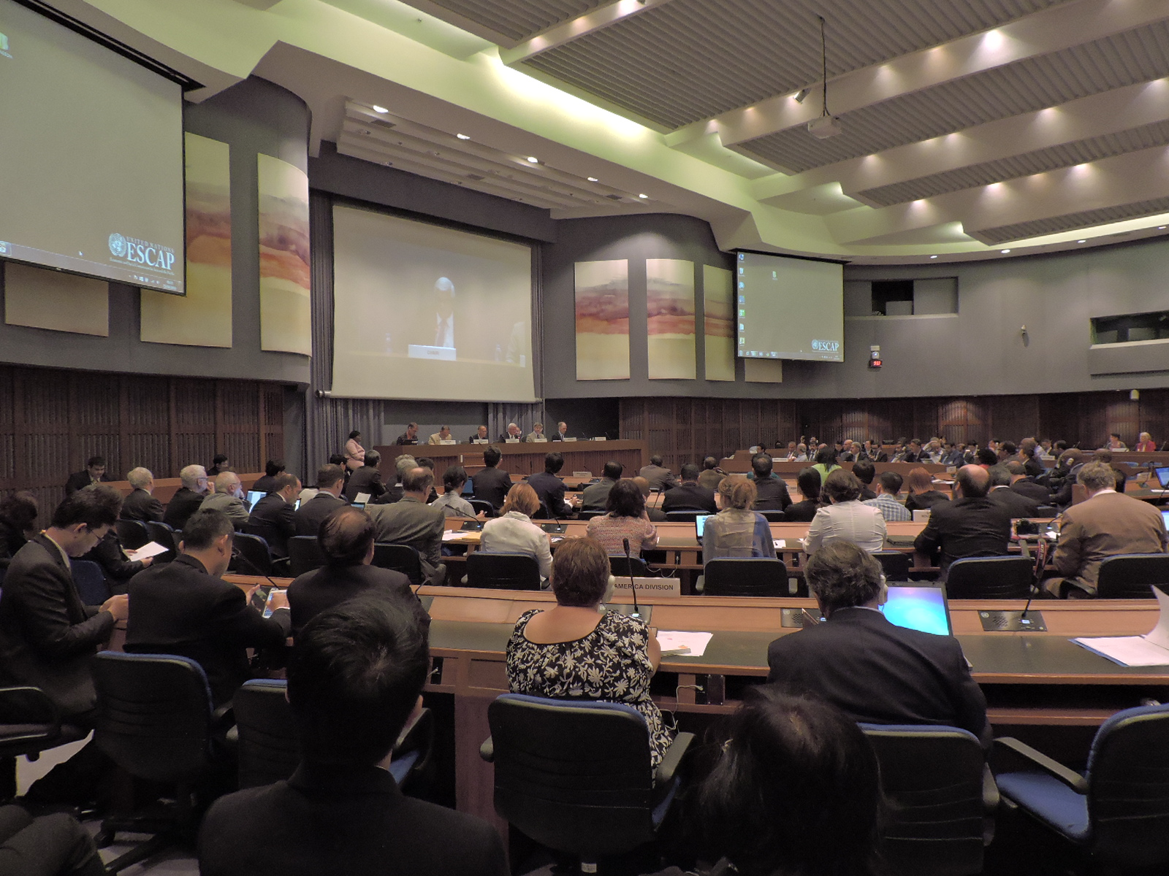

Fig. 1. The participants to the 29th UNGEGN Session, during William Watts’ speech

As we see, geographical names are the subject of important issues, to which many disciplines contribute, from history to geography, from linguistics to information technology. Place names have to be preserved from degradation and various risks, particularly because they are included in the UNESCO heritage list.
The 29th UNGEGN Session can also be seen on the website:
http://unstats.un.org/unsd/geoinfo/UNGEGN/sessions.html.
I wish to dwell my attention on two issues: (i) on the problem of exonyms, well developed for many years by my colleague and friend Peter Jordan, and (ii) the training courses on toponymy, well treated by Ferjan Ormeling.
Divisions and the working groups have organized special meetings as side events of the main session.
Peter Jordan, Vice Chair of the IGU-ICA Joint Commission on Toponymy, took the initiative to convene a meeting on April 28th with about thirty participants in the presence of the two Chairs Cosimo Palagiano and Paulo de Menezes. Peter Raper , Brahim Atoui, Ferjan Ormeling, Helen Kerfoot, Catherine Cheetham and other scholars also took part in the meeting. Peter Jordan outlined the numerous activities which the Joint Commission organized or co-organized since the last UNGEGN Session in 2014 (sessions during IGU Cracow, IGU Moscow, pre-conference symposion Rio de Janeiro, sessions within ICC Rio de Janeiro and EuGeo Budapest, symposion Clarens) and will organize or co-organize in 2016-2018 (e.g. in 2016 a session with 26 papers during the International Geographical Congress in Beijing). The activities of the Joint Commission are also documented on the website: www.igu-icatoponymy.org.

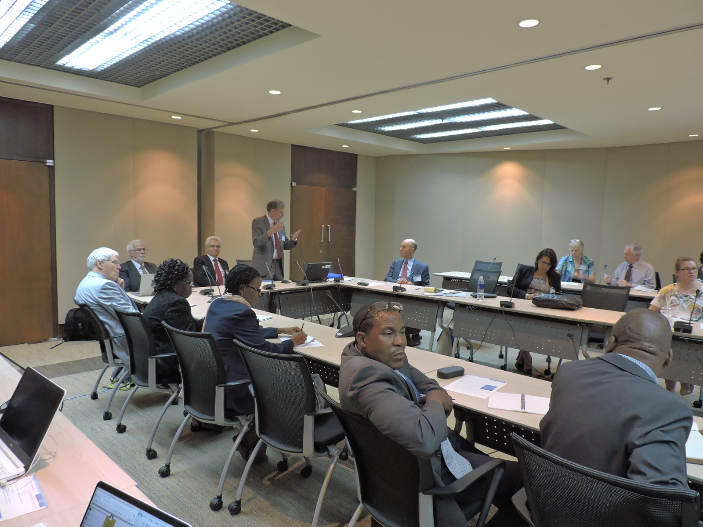

Fig. 2. The Joint IGU-ICA Commission meeting

Particular attention was paid to the Joint IG/ICA Commission’s plan to establish a consortium of universities devoted to toponymic education, which in accordance with the activities of the UNGEGN Working Group on Toponymic Training convened by Ferjan Ormeling aims at disseminating the knowledge on geographical names in several respects. This idea had been initiated by Peter Raper for South Africa, closely followed by Paulo de Menezes for Brazil. Cosimo Palagiano proposed to establish a link of universities between the two shores of the Mediterranean, immediately welcomed by Brahim Atoui.
Finally, I would indeed like to thank the secretariate of the Session, led by Cecille Blake, and also thank Stefan Schweinfest and Vilma Frani for their excellent work. Particular thanks go to William Watt, UNGEGN Chair, who very competently led the works of the Session.

Cosimo Palagiano

IGU observer of the UNGEGN 29th Session in Bangkok
IGU Chair of the IGU-ICA Joint Commission on Toponymy,
On behalf of Peter Jordan and Paulo de Menezes.

